**SQL EXAM ASSESSMENT(13-12-2023)**

1.Querying Data by Using Joins and Subqueries

 2.Manipulate data by using sql commands using groupby and having clause.

Creating the table and inserting values into it to perform the joins here.

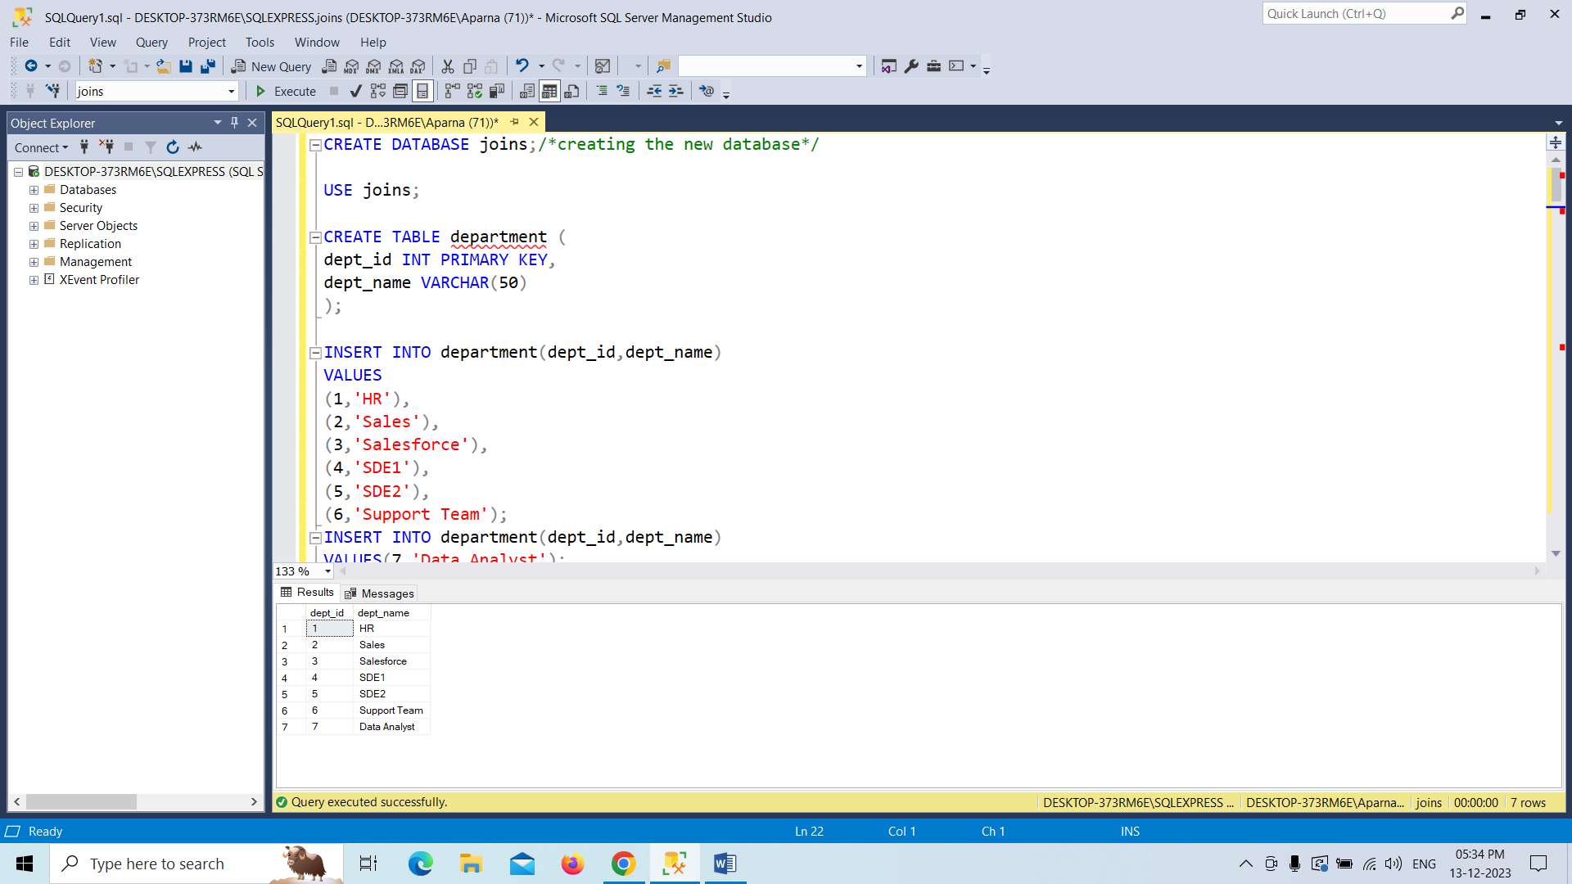

Creating the employee table and inserting and displaying the values into it

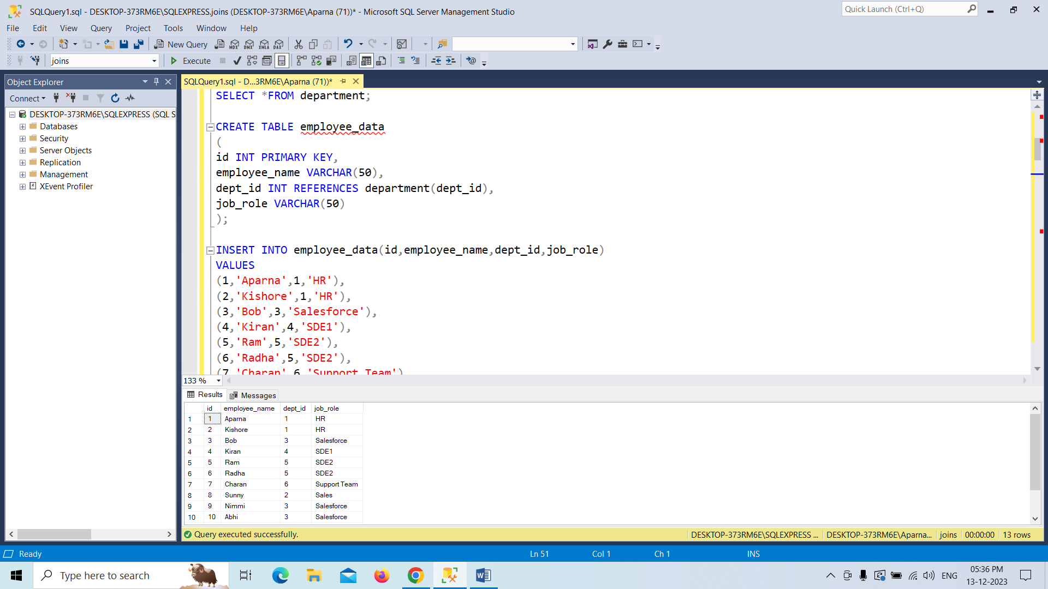

Performing the inner join between the two tables.

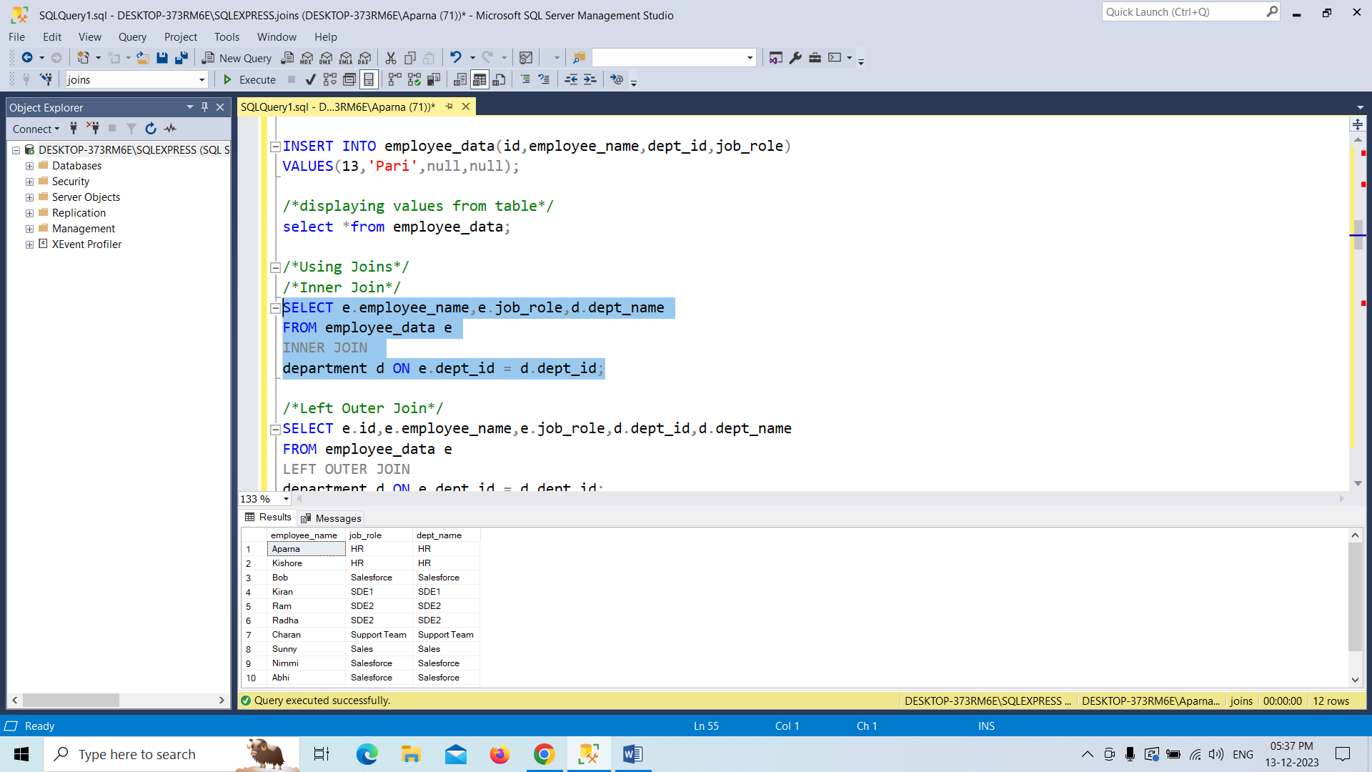

Performing the left outer join between the two tables.

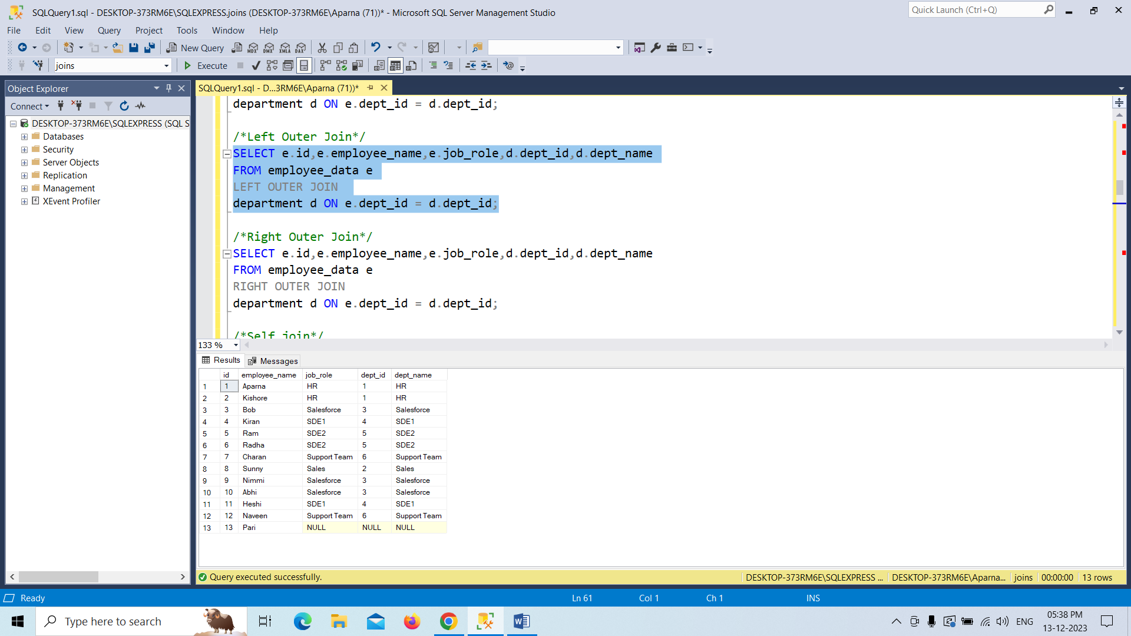

Performing the right outer join between the two tables.

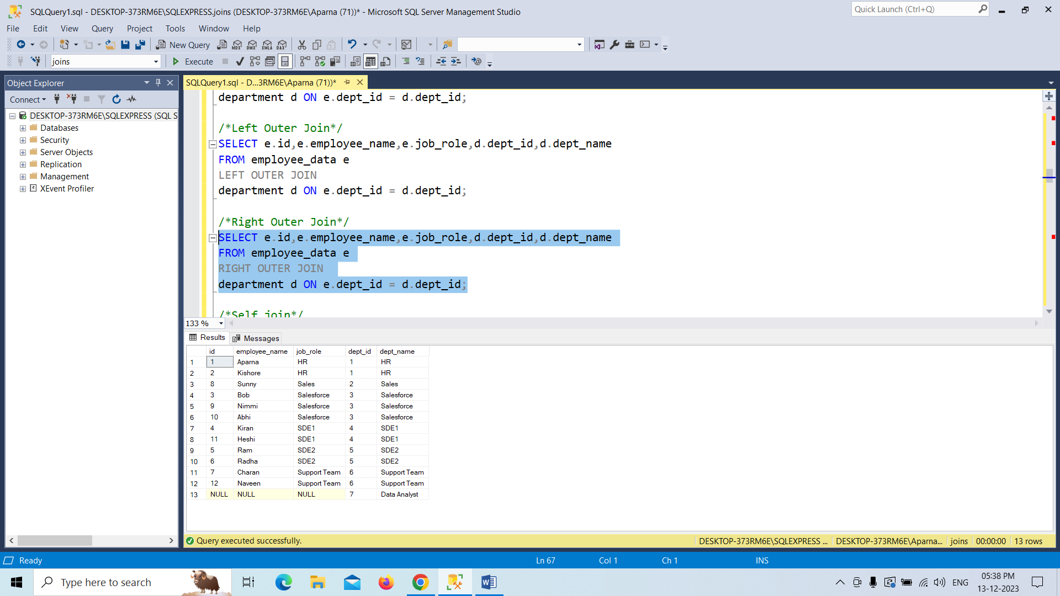

Performing the cross join between the two tables.

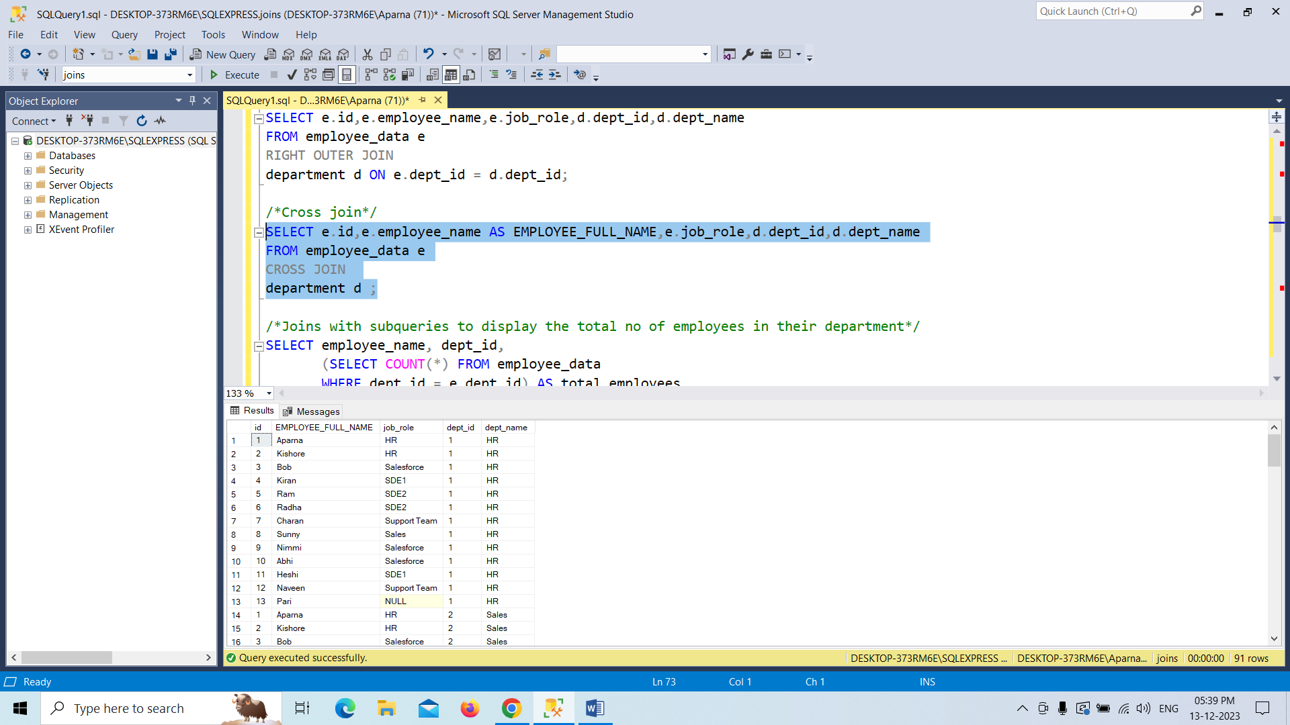

Perfoming the subquery to the table which contains atleat one employee in department.

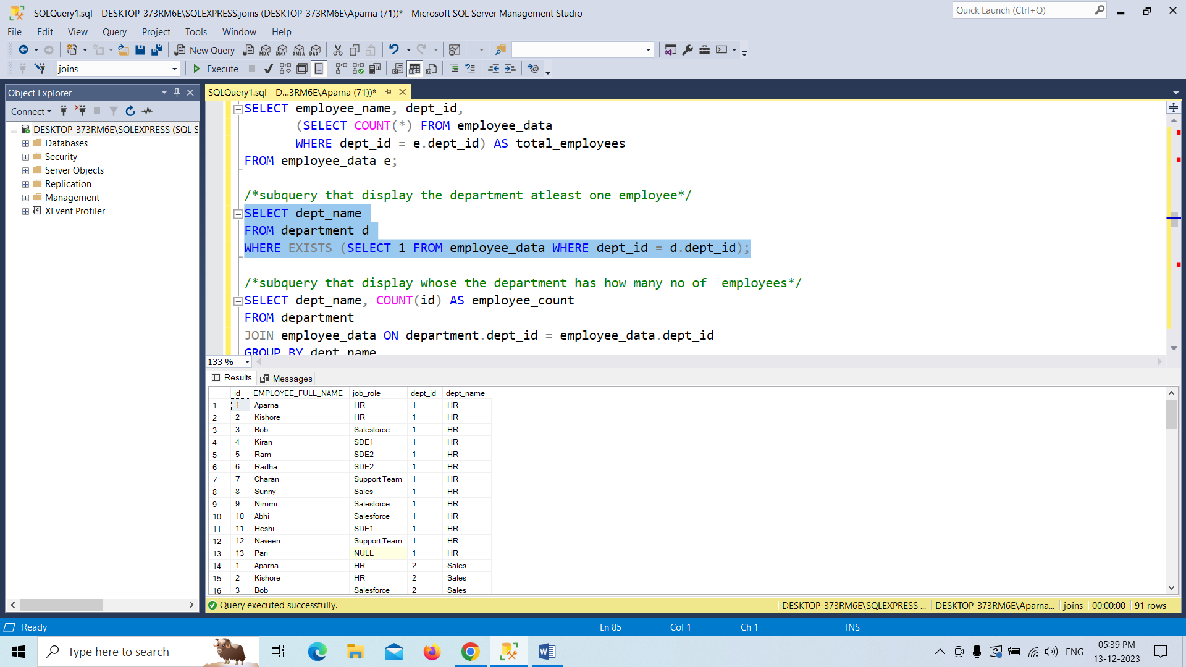

Performing the subquery to the table which contains how many people in each department.

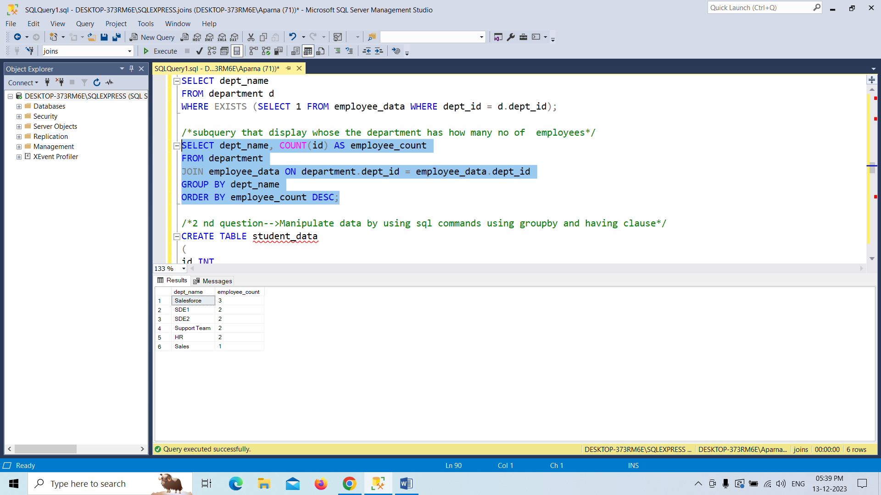

Creating the subquery to the table which contains atleat one employee in department.

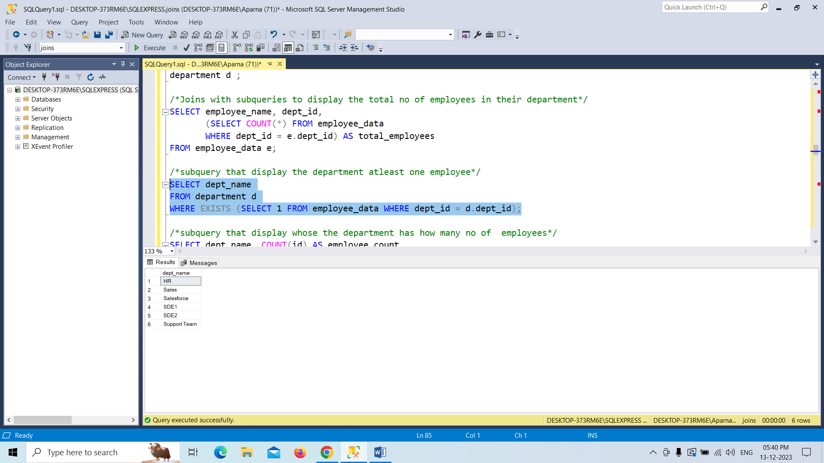

2 Question🡪Creating the student_data and inserting values into it.

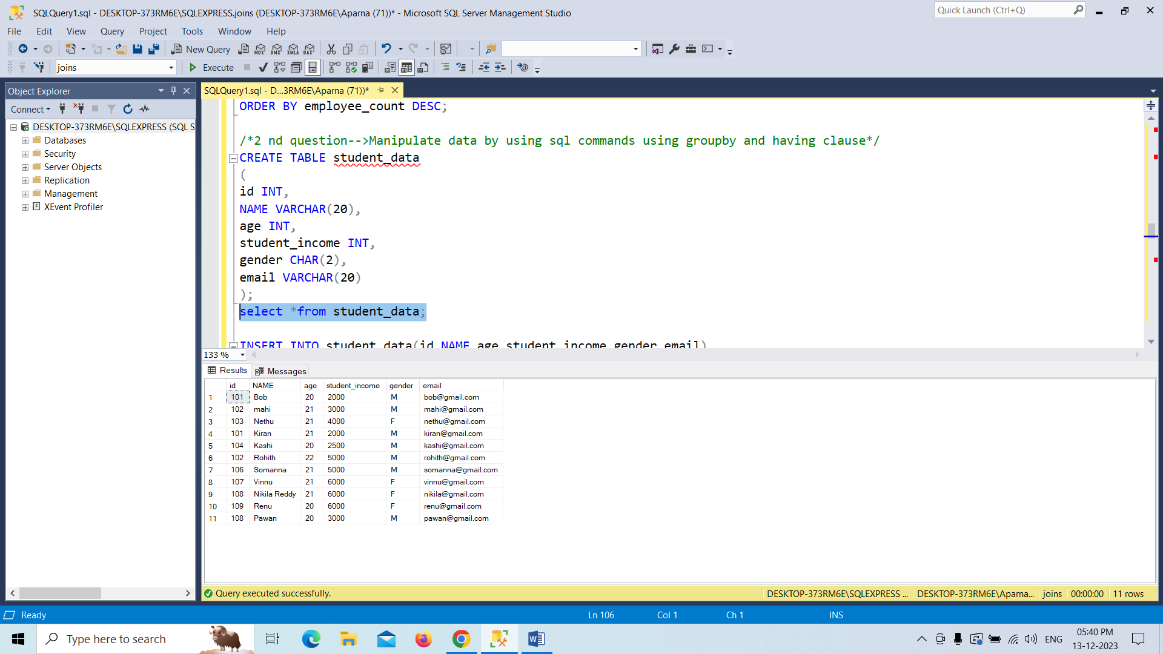

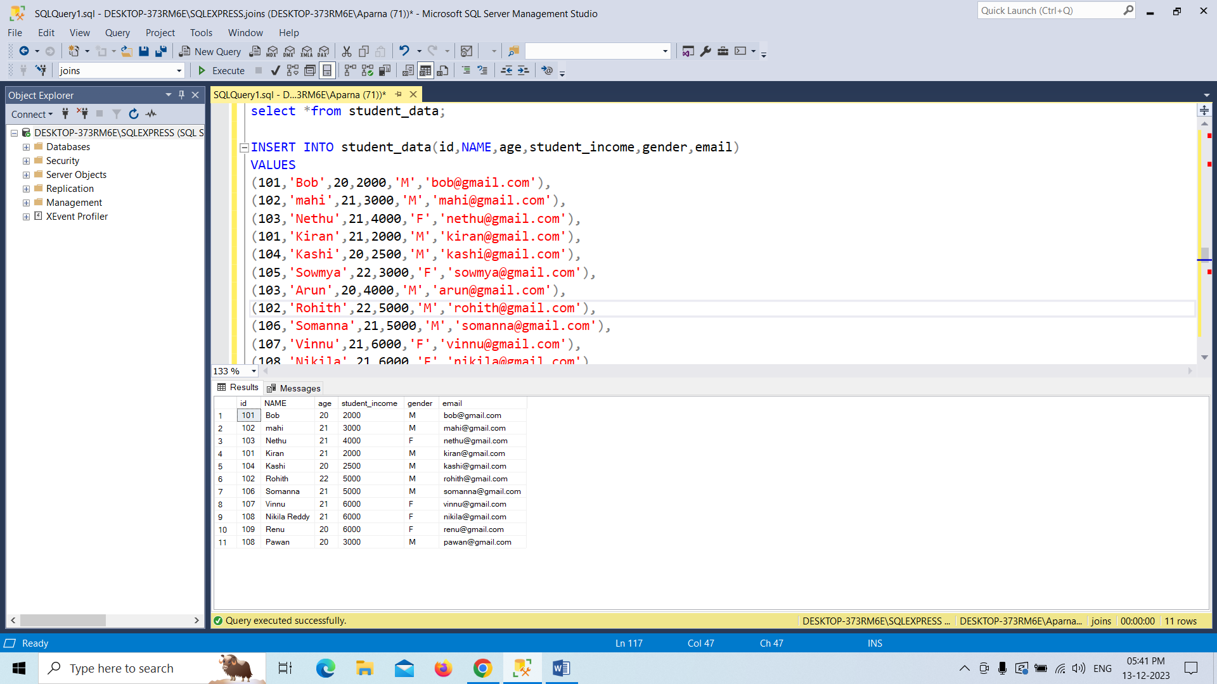

Updating the records into in the table.

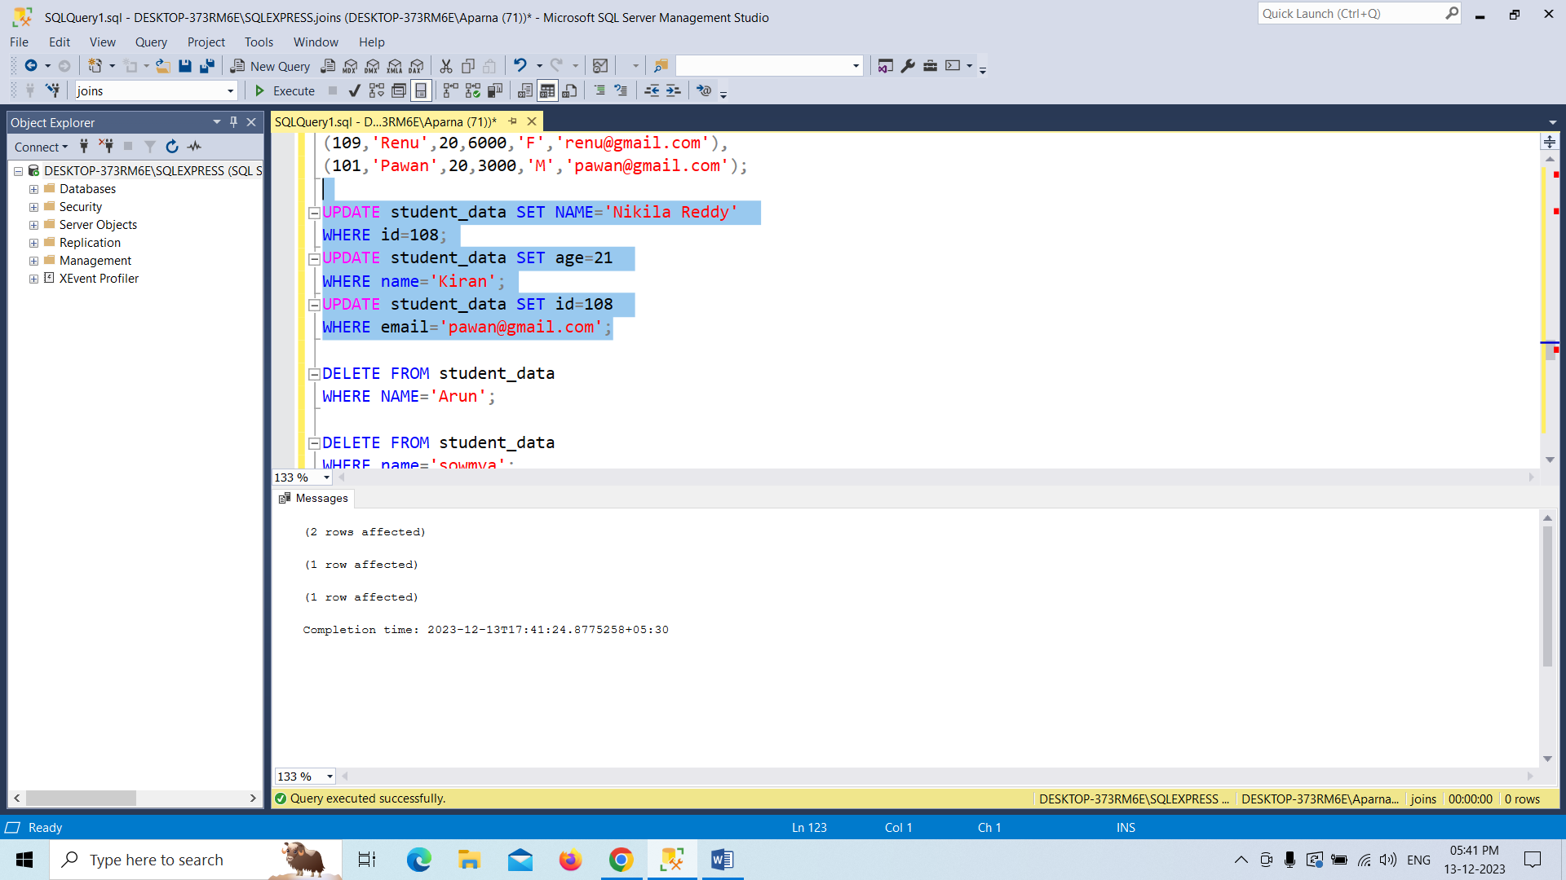

Deleting the records in the table.

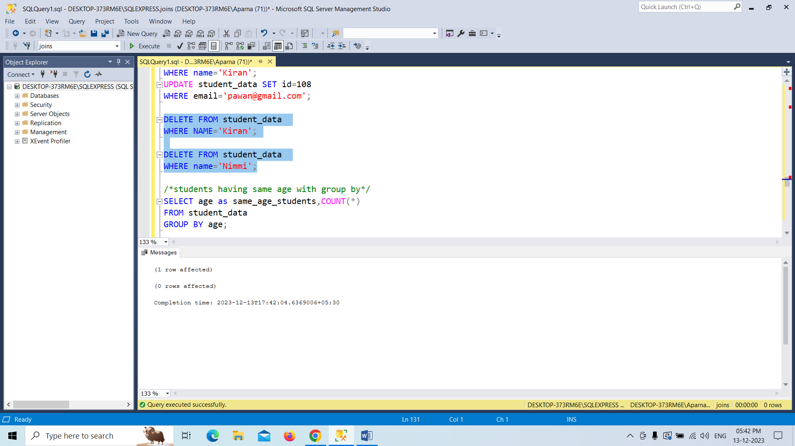

Here displaying that students having same age with group by clause.

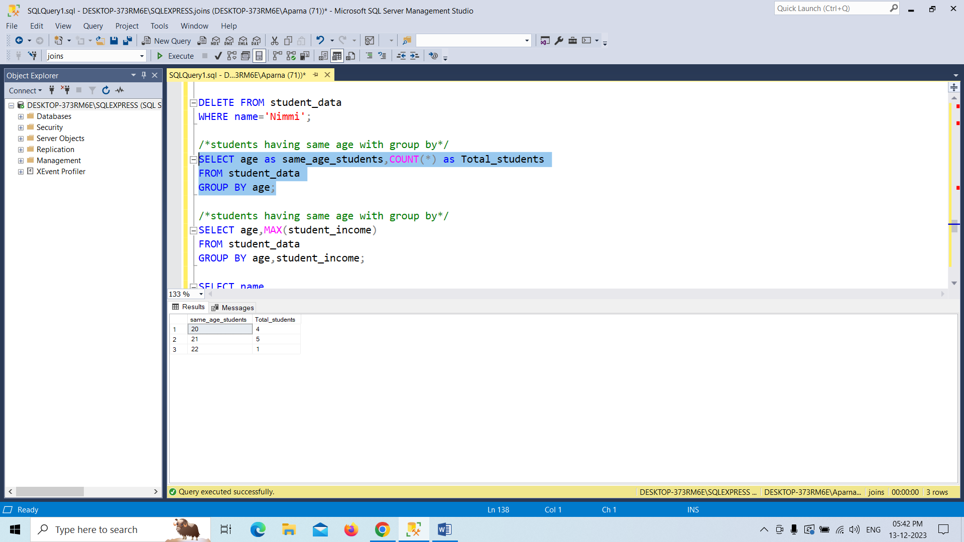

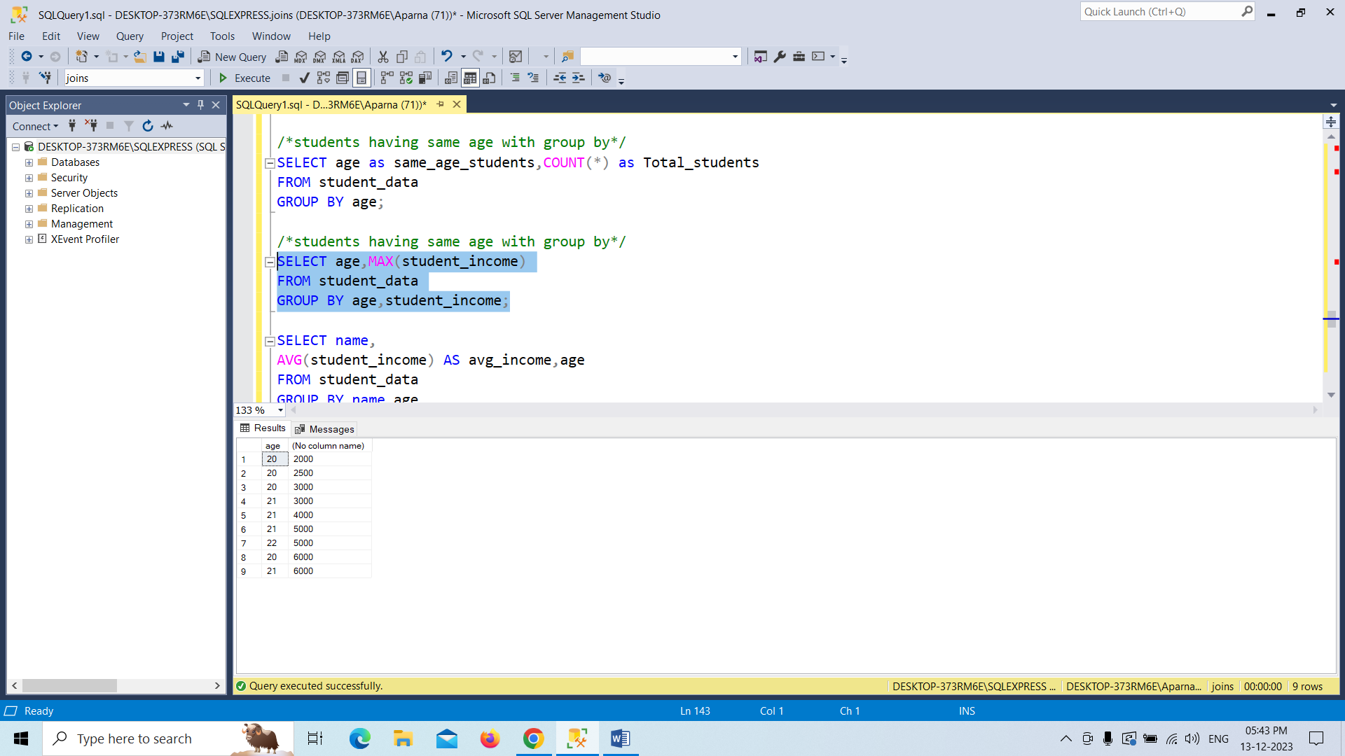

Here displaying the students avg_income with group by clause

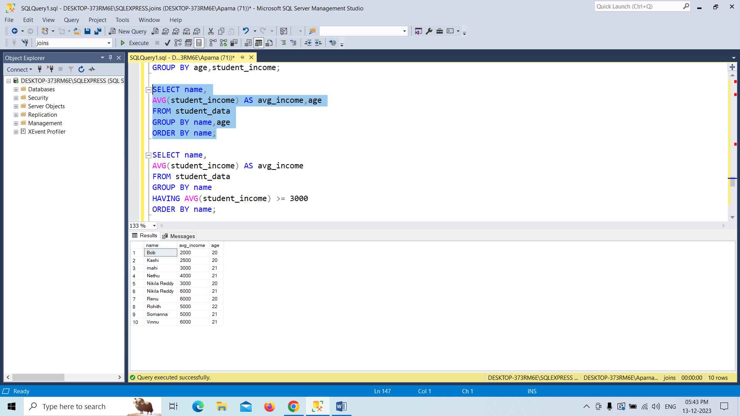

Here displaying the students avg_income whose income is greater than 3000 group by clause and having clause

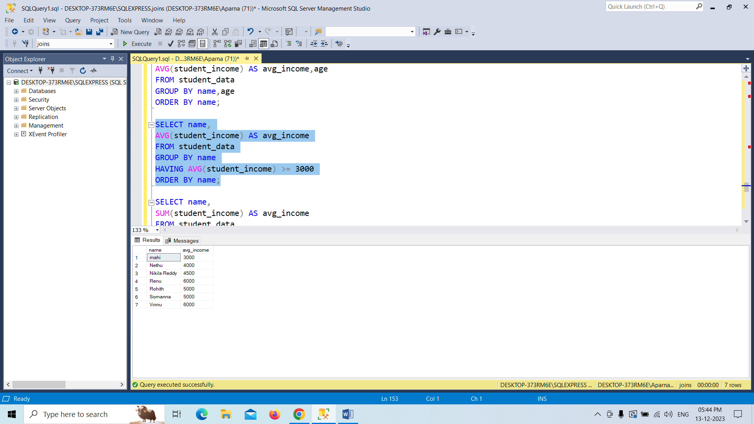

Here displaying the students sum of income whose income is greater than 5000 group by clause and having clause

